# Decision Tree in Sleep Stage Prediction Model

## Architecture

The initial decision tree was a default primitive decision tree offered by scikit-learn library of python. The default parameters for the architecture of the decision tree are shown as follows :-

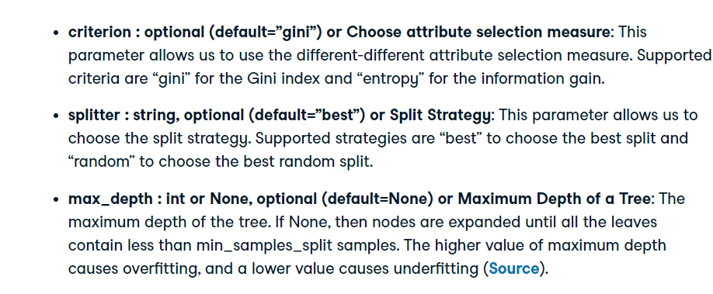

The parameters used in our model are :-



The {criterion=’entropy’} splits the data-set based on the weighted entropy of each attribute, in our case, the weighted entropy of each signal after normalizing.

The {max_depth=12} restricts the decision tree to a maximum depth of 12. As stated above, a too high value of maximum depth can cause overfitting, and a lower value causes underfitting. A maximum depth of 12 gives an optimum solution, which has been verified through K-fold Cross Validation.

## K-fold Cross Validation

We have performed K-fold cross validation to verify whether the model is undergoing overfitting or underfitting. We have first shuffled the dataset randomly. Then we have splitted the dataset into 5 sets/folds. Then we send 4 folds into training and 1 fold into testing. This is iterated until each fold goes into testing. K-fold cross validation has been very aptly and concisely demonstrated in the diagram given below.

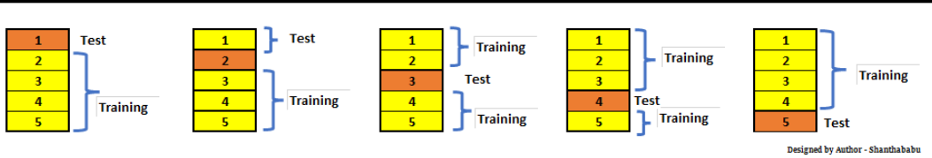

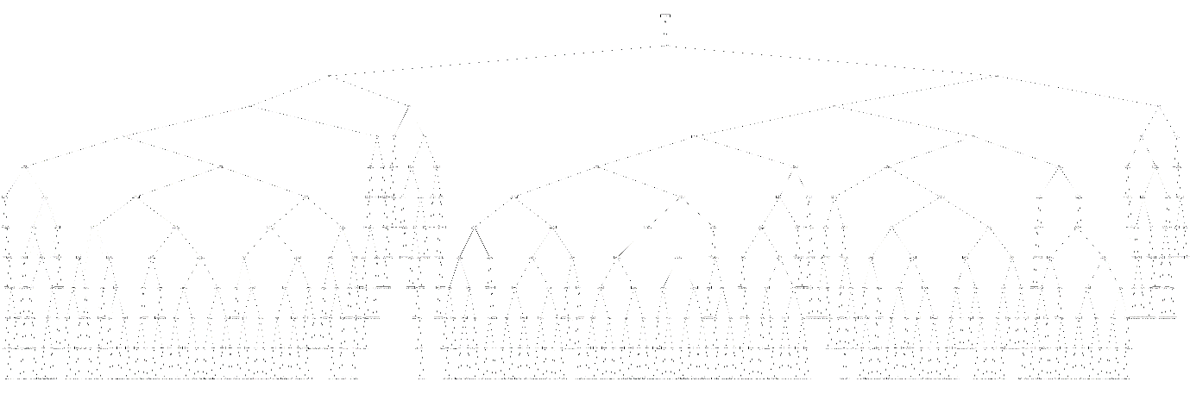

The above diagram gives an idea of how the decision tree looks. The picture is available in the github repository, for reference.

## Classification Report

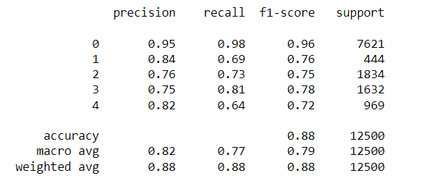

## Github Repository

<https://github.com/Jibitesh-Chakraborty2811/Sleep-Stage-Decision-Tree>